## After the Experiment

There should be one .smr file (jbeG010.smr), with eye movement data and text descriptions of all experiments. And a bunch of .nev and .ns5 files.

If you made RefClusters.mat online, copy this into the data directory on the Data Machine

**Copy Files onto the network.**

In Spike2 open jbeG010.smr. Then use script MakeMat. Hit button “just make .mat” This makes jbeG010.mat, the matlab file containing all the text and event times. Then “Make .em/lfp only”. Which makes jbeG010.em.mat a files containing all the eye movement data in an Expt structure.

**In Matlab**

[a, Expts] = APlaySpkFile((‘/Volumes/bgc8/Utah/jbe/jbeG010.mat’). Parses all the info in .mat file and constructs Expt struct for each completed (and not cancelled) experiment. To include Trials with bad fixation: APlaySpkFile((‘/Volumes/bgc8/Utah/jbe/jbeG010.mat’,’usealltrials’). Parsing all the text can take some time, so APlaySpkFile writes a File jbeG010idx.mat with the parsed text. Building Expts from this is much quicker so this is done anew every time APlaySpkFIle is called. Its called by each subsequent stage to get a list of time values over which spikes are to be found (Only in and around trials).

ProcessGridFullV(‘/Volumes/bgc8/Utah/jbe/jbeG010.mat’,’initial’,’refcut’, [’usealltrials’] ,[‘parallel’]);

This generates all of the FullV files need by AllVPcs.m. The argument ‘initial’ sets typical arguments required at first (see ProcessGridFullV help for list). ‘usealltrials’ if you want FullV to include trials terminated with bad fixation). It generates some temporary intermediate files of the form ‘jbeG010001rawp.mat’. (These are created to avoid multiple calls to the BlackRock library which can be very slow). It is safe to delete these, but best to check that the FullV files are working first – its much faster rebuilding FullV files if the ‘rawp’ files are there.

If you have the parallel processing toolbox an enough memory (1-2Gb per worker), you can use the ‘parallel’ option (start your matlabpool first) .

Once this is finished, it should be possible to cut/examine clusters using AllVPcs e.g.

AllVPcs(‘/Volumes/bgc8/Utah/jbe/Expt10.p1FullV.mat’,’reapply’);

Once Clusters have been cut for All Expts/Probes, the clusters can be (1) inspected quickly, and (2) assigned to cell numbers (in CellList.mat) with

PlotClusters(‘/Volumes/bgc8/Utah/jbe/Expt10.p1FullV.mat’,[’load’],[’usealltrials’])

The optional ‘load’ argument makes PlotClusters preload all of the Cluster information. It can take a couple of minutes, but makes subsequent operation much faster (if your machine has enough memory). This brings up a small control window, a image plot labeled “PlotClustersAll” (not much use) and an image plot labeled “PlotClustersCellList”, which is the business end. Rows are experiments, columns are probes. The color will show cell number assigned.

If you have marked some probes as good in RefClusters, these can be quickly assigned cell numbers with the menu:

Cells->Fill using marked.

Left clicking on any square brings up plots of the clustering details (depending on checkboxes checked in the control window):

“spkxy” XY plot of the 2D cluster space

“spkmean” mean spike waveform for cluster and non-cluster

“Histogram” plots a frequency histogram of the parameter used to classify

“quickpsks” shows a random selection of spike waveforms from this expt/probe

To assign a square to a cell, you can right click, and select the top submenu (labeled ExPx).Colored entries mean that this cell number is already used elsewhere in the grid, so be sure you mean it is the same cell. Black numbers are currently unused:

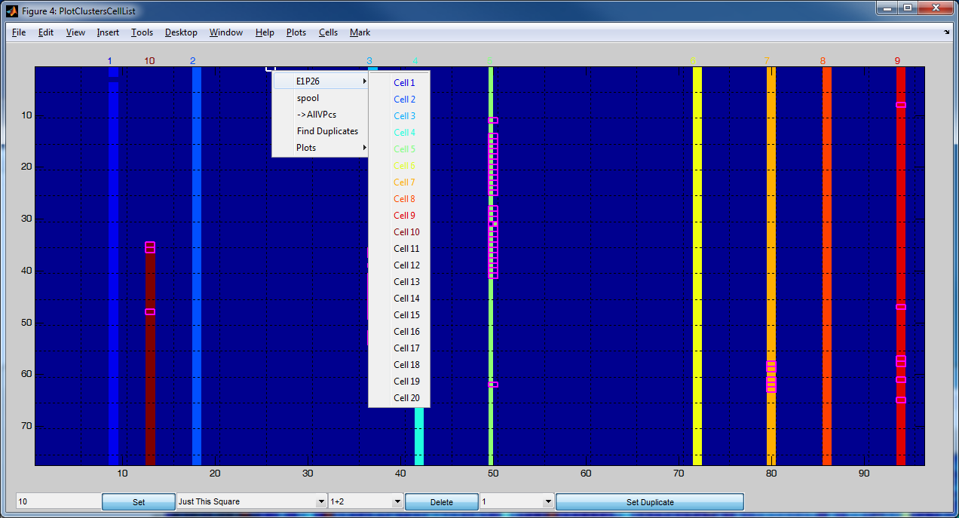

You can also assign a cell number by selecting a number in the lower left popup menu and then hitting “Set” .

Shift-click selects a block, control-click allows selection of multiple single squares.

Four handy plots for quickly seeing what is up are

Plots->Probes->AllXY this probe makes a subplot for each experiment and shows the XY plot for the selected probe. For good cells, you can see its good all the way. Or not……

Plots->Probes->AllXY this Expt. Shows the xy plot for all probes, just for the current experiment. I plot this for 4-5 Experiments spread through the day to see if there are cells that come up at different times not on my list

Plots->Probes->All Spks This probe Shows spike waveforms from every experiment for selected probe

Plots->Probes->All Spks This Expt Shows spike waveforms from every probe for selected expt

The AllSpks plots are useful reality checks. Sometimes the XY plots go into a silly space and hide the fact there is a cluster. If you can’t see an obvious waveform in the Spks plot, and there is only one “lump” in the XY plot, there is probably not a cell there.